ARIMA Mean Process Modeling and Residual Diagnostics

ACF and PACF Analysis
Autocorrelation Function (ACF) and Partial Autocorrelation Function (PACF) plots were generated for the daily log returns of AAPL, MSFT, and SPY. The return series exhibited relatively weak autocorrelation structures, which is consistent with the Efficient Market Hypothesis (EMH), suggesting that most linear predictability in stock returns is limited. However, several statistically significant spikes were observed at lower lags, indicating the presence of short-memory dynamics suitable for ARIMA modeling.
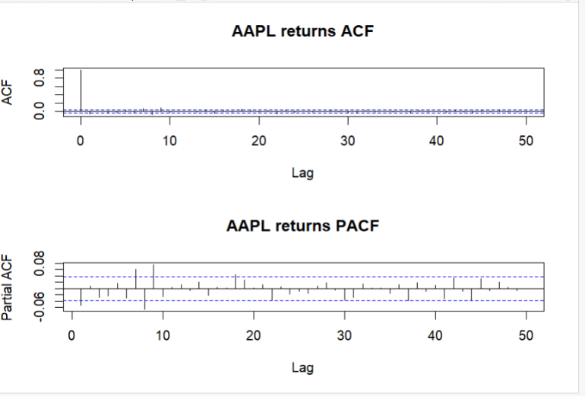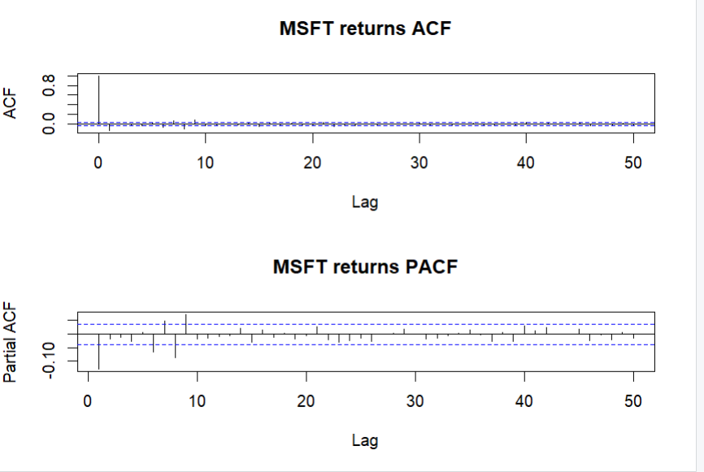

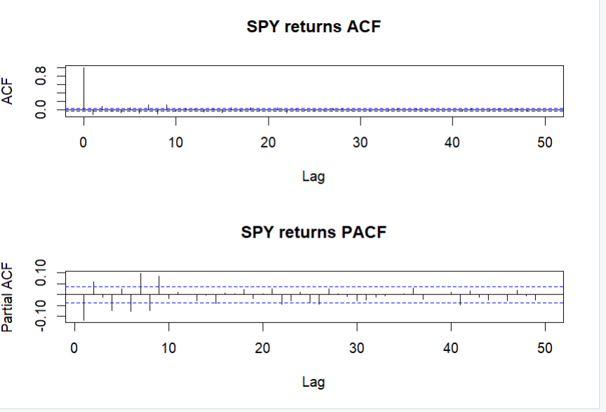

ARIMA Model Estimation
The optimal ARIMA specifications were selected using the auto.arima() procedure based on information criteria (AIC, AICc, and BIC).
The selected models were:
Asset | Selected Model
AAPL | ARIMA(4,0,1)
MSFT | ARIMA(4,0,1)
SPY | ARIMA(2,0,2)
All models were estimated on stationary log-return series. The estimated mean terms were small but positive, reflecting the long-run positive drift commonly observed in equity markets.

Residual Extraction
Innovation residuals were extracted from each fitted ARIMA model. These residuals represent the unexplained component of the return process after accounting for the estimated linear temporal dependence structure. The residual series were subsequently used for diagnostic testing and later served as inputs to the GARCH volatility modeling framework.

Durbin-Watson Test
The Durbin-Watson test was applied to assess first-order serial correlation in the ARIMA residuals.
Asset | DW Statistic | p-value
AAPL | 1.9954 | 0.4519
MSFT | 1.9965 | 0.4635
SPY | 1.9869 | 0.3655
All Durbin-Watson statistics were extremely close to the theoretical value of 2, and the corresponding p-values were not statistically significant. Therefore, the null hypothesis of no first-order autocorrelation could not be rejected. This indicates that the ARIMA models successfully removed lag-1 serial dependence from the return series.

Ljung-Box Residual Diagnostic
To assess residual autocorrelation across multiple lags, the Ljung-Box test was performed using 20 lags.
Asset | Ljung-Box Statistic | p-value
AAPL | 34.005 | 0.0261
MSFT | 39.843 | 0.0052
SPY | 20.345 | 0.4365
For AAPL and MSFT, the null hypothesis of no residual autocorrelation was rejected at the 5% significance level. This indicates that some higher-order dependence remained in the residual series after ARIMA fitting. Consequently, the residuals cannot be considered independent and identically distributed (IID) for these two assets.
For SPY, the null hypothesis could not be rejected, suggesting that residual autocorrelation was adequately removed.
The Ljung-Box results therefore indicate that the ARIMA models captured a substantial portion of the linear dependence structure but did not completely eliminate all serial dependence, particularly for AAPL and MSFT.

AAPL residual checking
checkresiduals(aapl_arima)

Ljung-Box test

data: Residuals from ARIMA(4,0,1) with non-zero mean
Q* = 16.986, df = 5, p-value = 0.004526

Model df: 5. Total lags used: 10

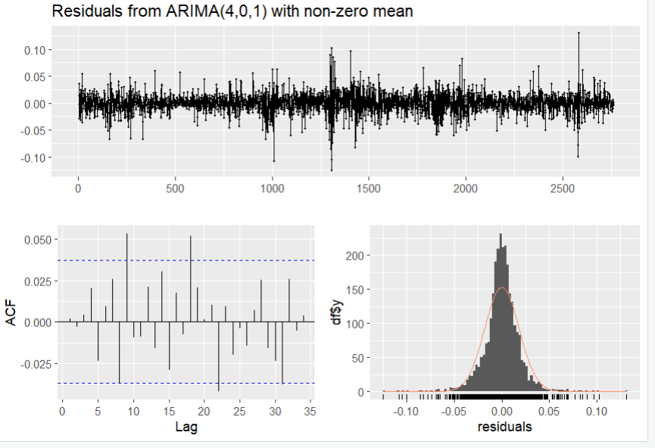
MSFT residual checking
checkresiduals(msft_arima)

Ljung-Box test

data: Residuals from ARIMA(4,0,1) with non-zero mean
Q* = 23.516, df = 5, p-value = 0.0002688

Model df: 5. Total lags used: 10

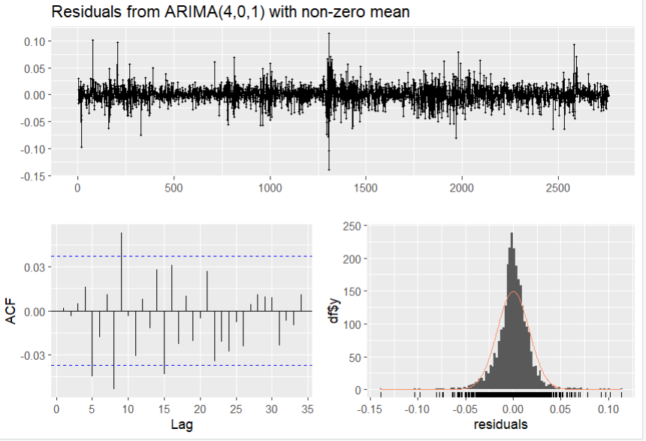
SPY residual checking
checkresiduals(spy_arima)

Ljung-Box test

data: Residuals from ARIMA(2,0,2) with non-zero mean
Q* = 13.59, df = 6, p-value = 0.03457

Model df: 4. Total lags used: 10

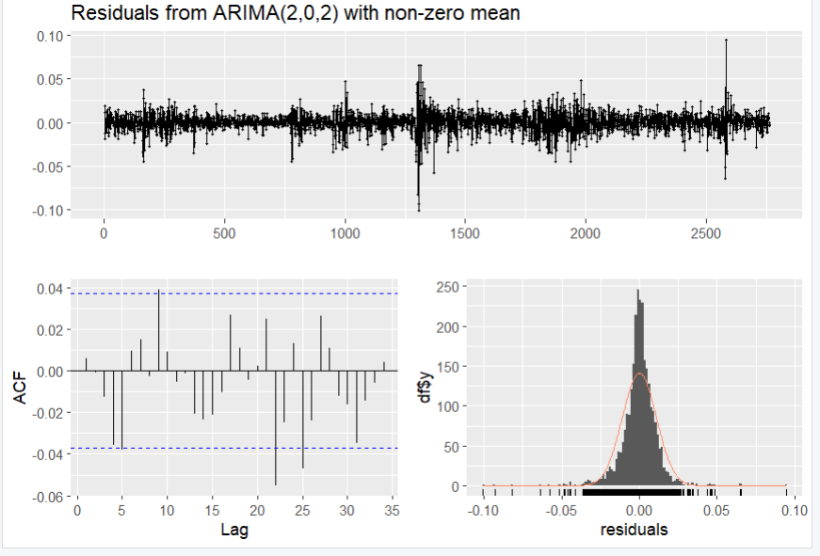

ARCH-LM Test
The ARCH-LM test was conducted to determine whether volatility clustering remained in the residual series.
Asset | ARCH Statistic | p-value
AAPL | 368.39 | < 0.001
MSFT | 433.12 | < 0.001
SPY | 696.43 | < 0.001
For all three assets, the null hypothesis of homoskedastic residuals was strongly rejected. The highly significant ARCH statistics indicate substantial conditional heteroskedasticity and volatility clustering within the residuals.

Interpretation
The ARIMA models successfully captured the majority of the mean dynamics present in the return series, as evidenced by the Durbin-Watson results and the largely flat residual autocorrelation functions. However, the Ljung-Box tests revealed that residuals for AAPL and MSFT were not fully IID, indicating the presence of remaining higher-order serial dependence. More importantly, the ARCH-LM tests provided overwhelming evidence of conditional heteroskedasticity across all assets.
These findings suggest that while ARIMA adequately modeled the conditional mean process, significant volatility dynamics remained unexplained. Therefore, a GARCH-family model is required to capture time-varying conditional variance and volatility clustering. The extracted ARIMA residuals were consequently used as inputs for the subsequent GARCH modeling stage.

